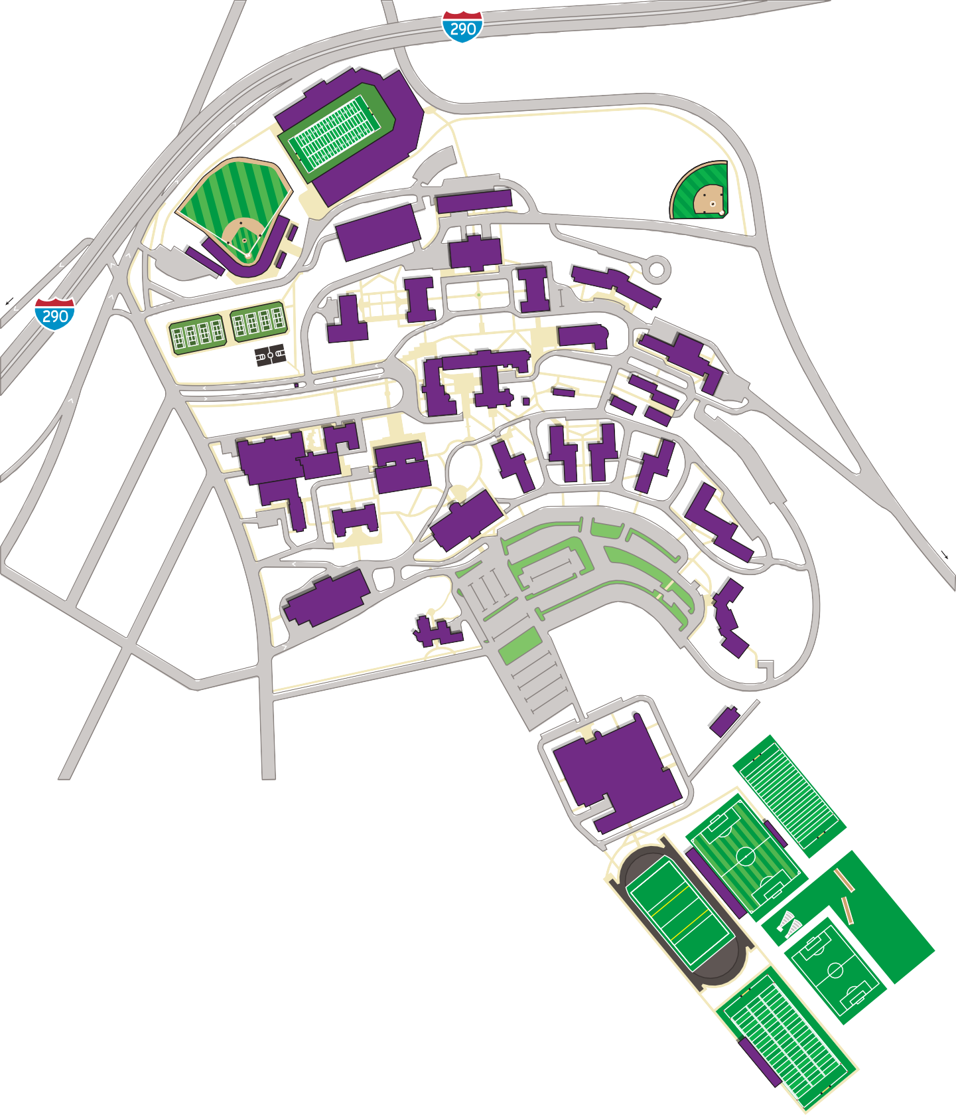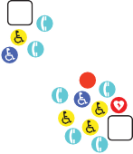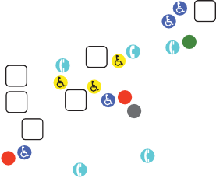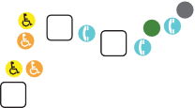

31

P
P

30 D 39 32
40 D
P

G0

G G1

29

G2
L

G3
9
D
G4 8

7
P P
P 20

11
G

P

1
G

5

D 4
6
P

21
D D

38
18
19 P

35
2
3 36
WALK DOWN STAIRS AT RIGHT SIDE OF HOGAN CAMPUS CENTER (#33). FOLLOW WALKWAY TO THE RIGHT, CROSS THE STREET AND ENTER SMITH HALL (#3). GO DOWN ONE FLIGHT TO 2ND FLOOR.
D
37

16 15 14

Lot 1

P

17 G
D
G

10

13

12
G

Loyola Lot
P G

G5 P

G6

28

G7
33
D
G

G
PARK HERE
34 D
G
P P

Lot A P P

Lot B P P

Lot 2

P

P Lot 3
P Lot 4

P
Lot 1
P
Lot 2 G

22

Lot C P P
ENTER GATE 7 AT TOP OF HILL ON COLLEGE STREET
P

CAMPUS FACILITIES

Academic Buildings
1 O’Kane Hall
(Fenwick Theatre, Dance Studio,
23

Athletic Facilities P
23 Hart Recreation Center
Smith Wellness Center

Cantor Art Gallery, Public Safety)
- Fenwick Hall
(Admissions, Brooks Concert Hall)
- Smith Hall
(Registrar, Class Deans, Center for Religion, Ethics and Culture)
- Dinand Library
Integrated Science Complex
- Beaven Hall
- Smith Laboratories
- O’Neil Hall
- Swords Hall
- Haberlin Hall
- Millard Art Center
- Stein Hall

Residence Halls
- Mulledy Hall
- Clark Hall
- Hanselman Hall
Basketball Arena (3,600 seats)
Swimming Pool (250 seats)
Ice Hockey Arena (1,050 seats)
Rowing Tanks
- Johnson Smith Soccer Stadium
(1,350 seats)
- Playing/Practice Fields
- Holy Cross Field
(Lacrosse/football practice; 1,000 seats)
- Artificial Turf Field and Track
- Fieldhouse
- Sinnott Family Tennis Facility
- Fitton Baseball Field (3,000 seats)
- Fitton Football Field (23,500 seats)
- Softball Field / Freshman Field

Other Facilities
- Hogan Campus Center
- Ciampi Hall ( Jesuit Community)
- St. Joseph Memorial Chapel

24 25
27

26

Produced for College of the Holy Cross by mapformation LLC. Last updated August 9, 2013.

  - Lehy Hall
  - Healy Hall
  - Loyola Hall
  - Williams Hall
(Mary Chapel, McCooey Chapel)
- Greenhouse
- Campion House (Chaplains’ Office)
- Kimball Hall
P Student Parking
P Employee Parking
G Gate
Accessible Entrance
AEDs (Defibulators) Emergency Call Box

- Alumni Hall
- Carlin Hall
- Wheeler Hall
- Figge Hall
(Student Dining, Seelos Theater)
- Maintenance Building
- Parking Garage
P Visitor Parking

Accessible Parking
Wheelchair Lift
D Shipping & Receiving Dock

